**Concept Vision**

Contents

[Purpose 1](#_Toc530718369)

[Motivation 2](#_Toc530718370)

[Visual aspects 3](#_Toc530718371)

[Digital art 3](#_Toc530718372)

[Hand-drawn art 5](#_Toc530718373)

[Artefact concept 6](#_Toc530718374)

[Artefact Designs 7](#_Toc530718375)

[Low-Level Prototypes 8](#_Toc530718376)

[Main menu 8](#_Toc530718377)

[Sign without poster 8](#_Toc530718379)

[Sign with poster 9](#_Toc530718380)

[Storyboards 10](#_Toc530718381)

[Shayna’s Storyboard 10](#_Toc530718382)

[Jacob’s Storyboard 11](#_Toc530718383)

[Aaron’s Storyboard 12](#_Toc530718385)

[Dominic’s Storyboard 13](#_Toc530718386)

[User Interface Sketches 14](#_Toc530718387)

[Project Plan 15](#_Toc530718388)

[Team Members 15](#_Toc530718389)

# Purpose

The general purpose of picking a bike rental service for the intended artefact is targeting various audiences for example; elderly might use the park for walking and be interest in interacting with these rental bikes due to them being restricted in movement and wanting to discover various areas. Not only would the elderly be interested but youth and families could also be interested as they would want to discover new experiences and maintain a healthy and proactive lifestyle.­­

The enjoyment of riding a bike is the main reason why bike rental maybe of large appeal due to the observation and having the chance to see a lot more than the user would, if they were to run or walk. Observation is not the main intention of walking the main purpose is to get from one area to the next, not observing the environment as much.

# Motivation

As the population increases, public transport becomes a major problem due to the fuel which is burnt which as a result; emits damaging gases into the environment. This can cause a lot damage which would require funds to fix and as a result; making the government spend money where it doesn’t have to be. The money spent trying to combat this issue could be used to research various fuel alternatives and thus; making the planet a cleaner place.

In the construction process of these bikes, less materials need to be used which would aid in rationing the planet’s resources and making sure that less transportation systems need to be used to transport them. Less fuel is being burnt because of these restrictions, making less resources to be used to perform these actions which leads to better general maintenance and more consistent repairs.

Making promotional events to advertise this service would make others more aware of the products available to the public which would then allow for various users to communicate with each other and promote the service further.

# Visual aspects

## Digital art

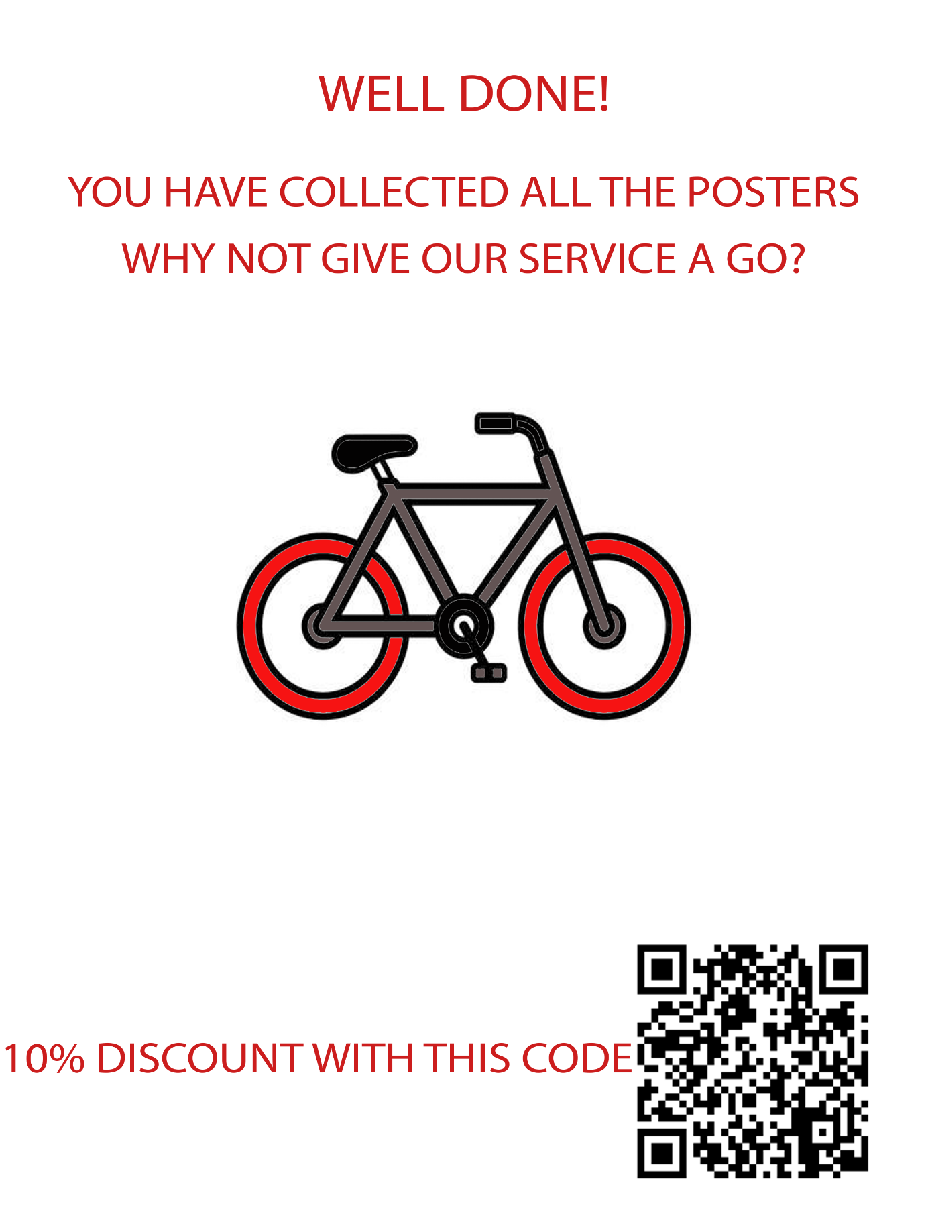

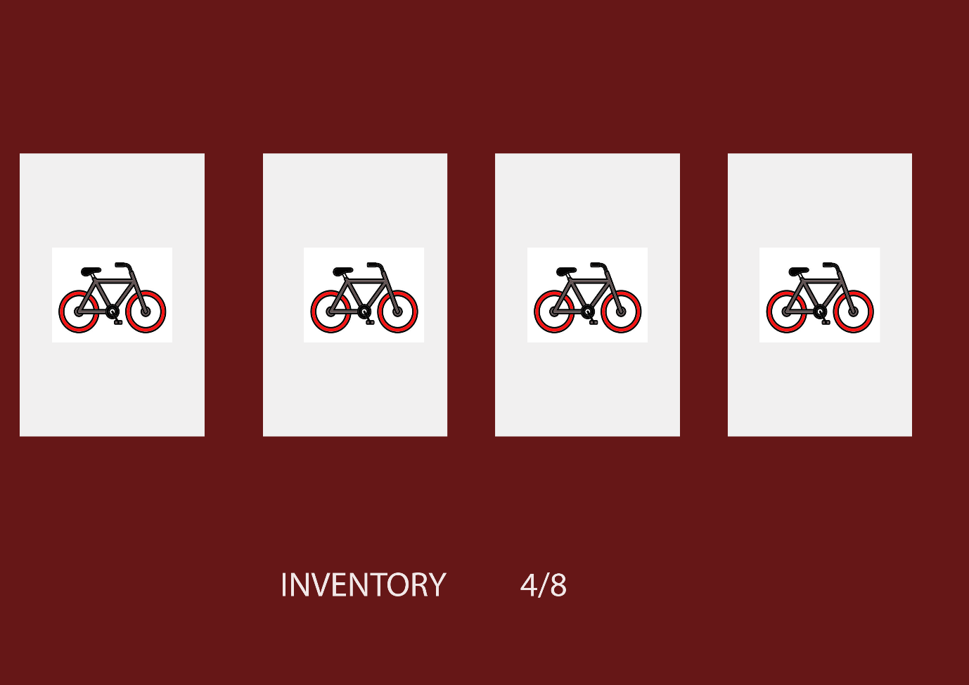

## Hand-drawn art

# Artefact concept

The concept of the artefact is an advertisement for a bike rental service around a set setting. In this case a park. Around the park there will be posters that are advertising the bike rental service. The player walks around the park and collects the posters. After a set amount of posters is collected, the player wins and is taken to the website for the bike rental service or a point in the “game” that resembles the bike rental service with all the information. There is a possibility after collecting the posters that the player would be able to cycle/walk to a resemblance of the bike rental service.

There will be other characters in the virtual environment, such as animals and joggers as NPCs. The player cannot directly interact with these characters, but notices/views their movements.

## Artefact Designs

## Low-Level Prototypes

## Main menu

## C:\Users\Dominiq\AppData\Local\Microsoft\Windows\INetCache\Content.Word\Menu.png

## Sign without poster

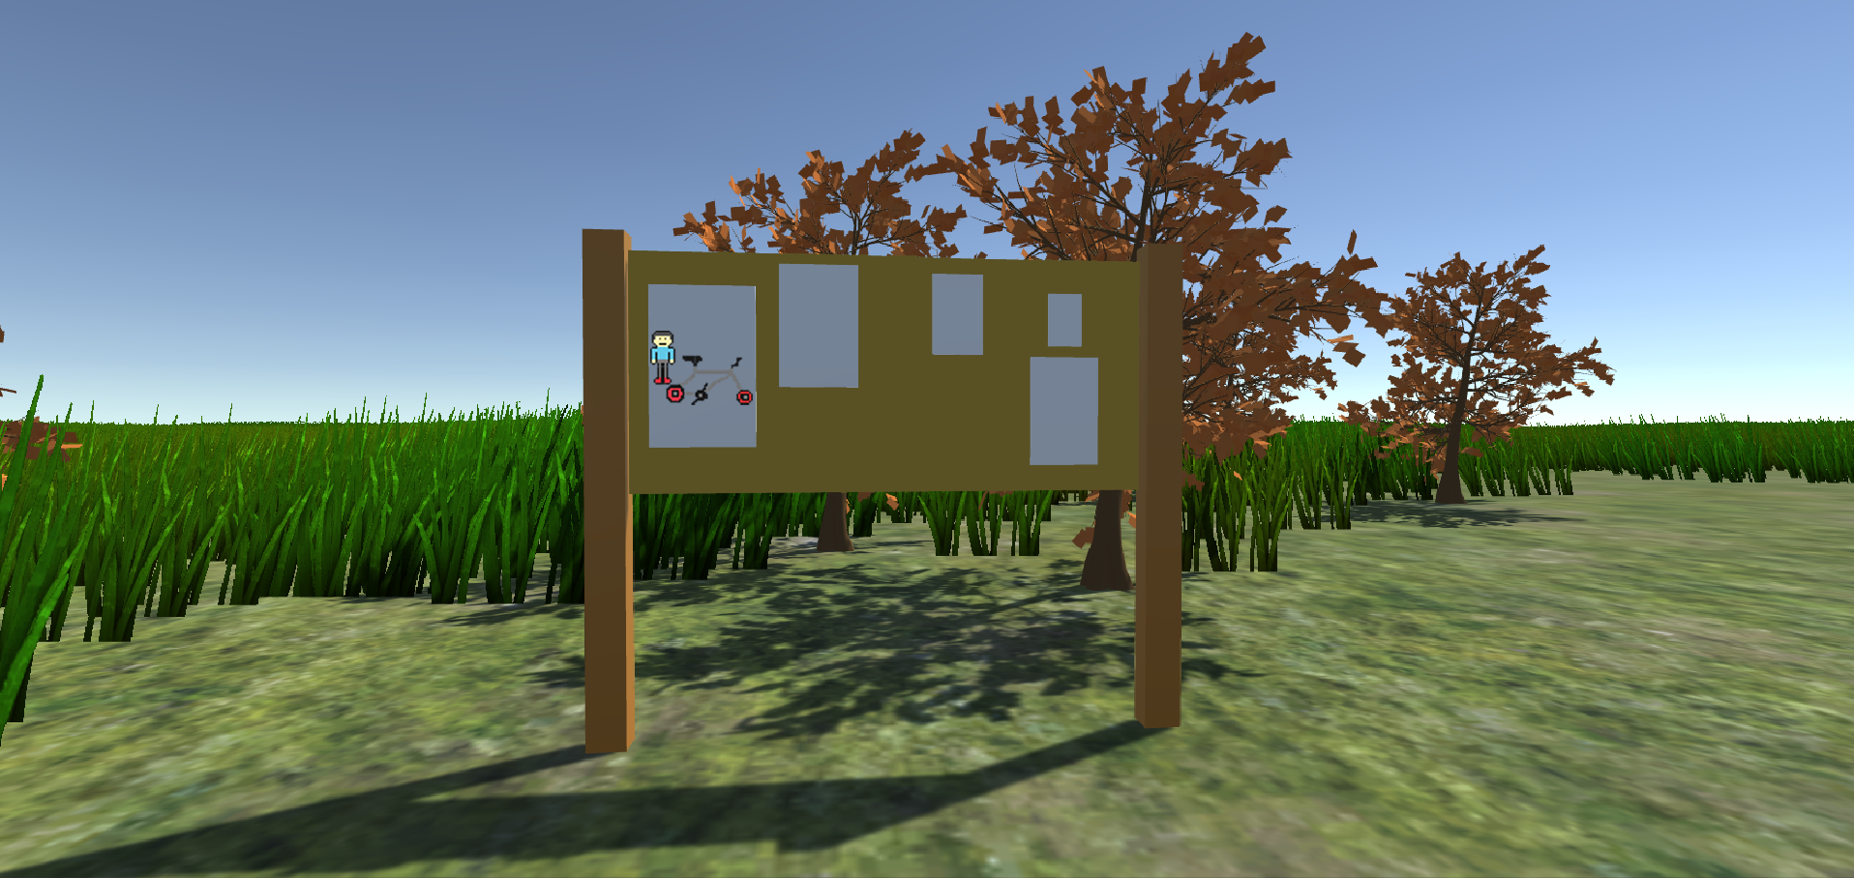

## Sign with poster

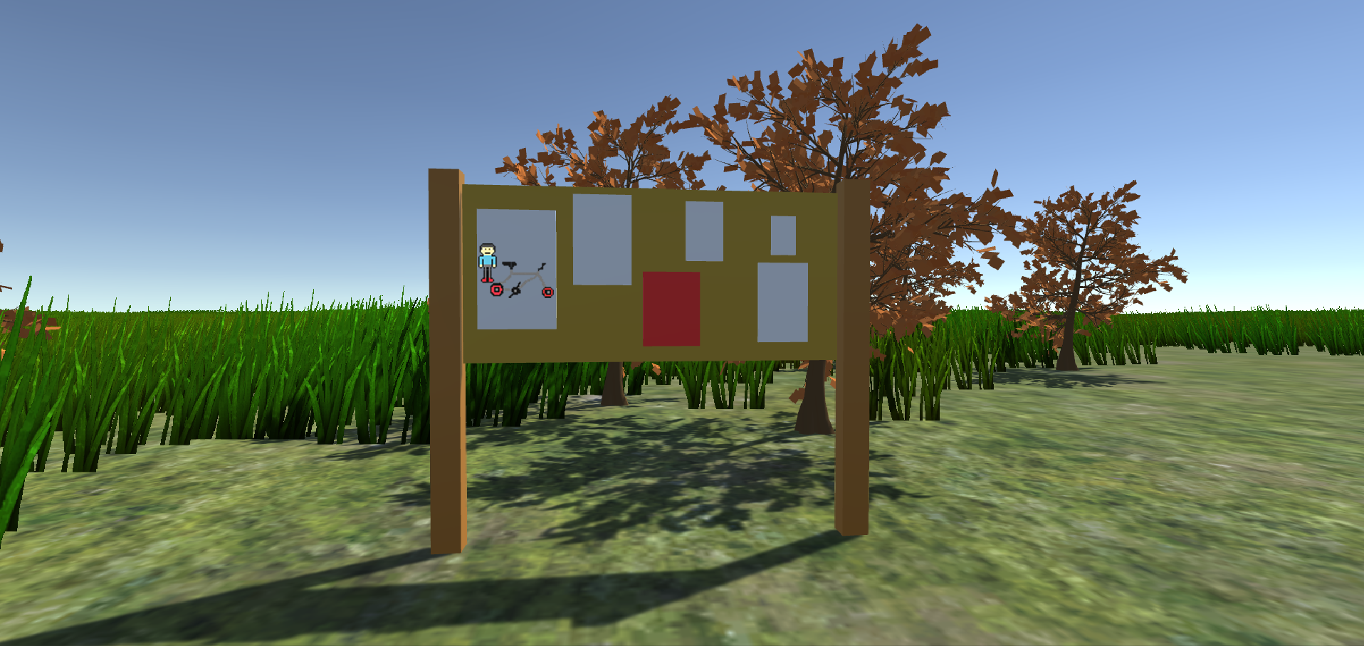

# Storyboards

## Shayna’s Storyboard

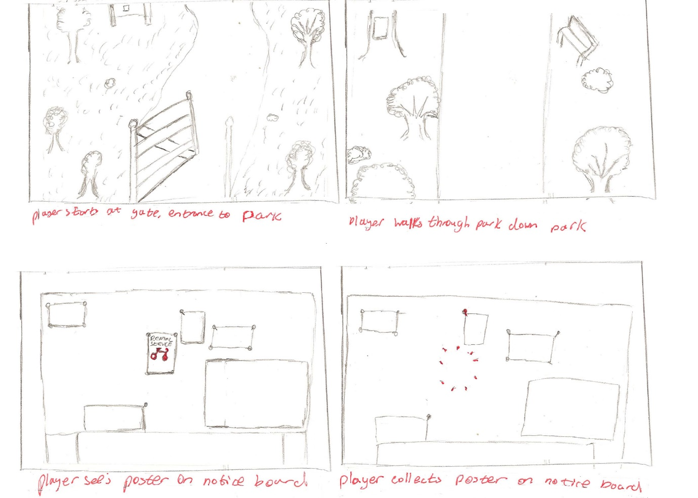

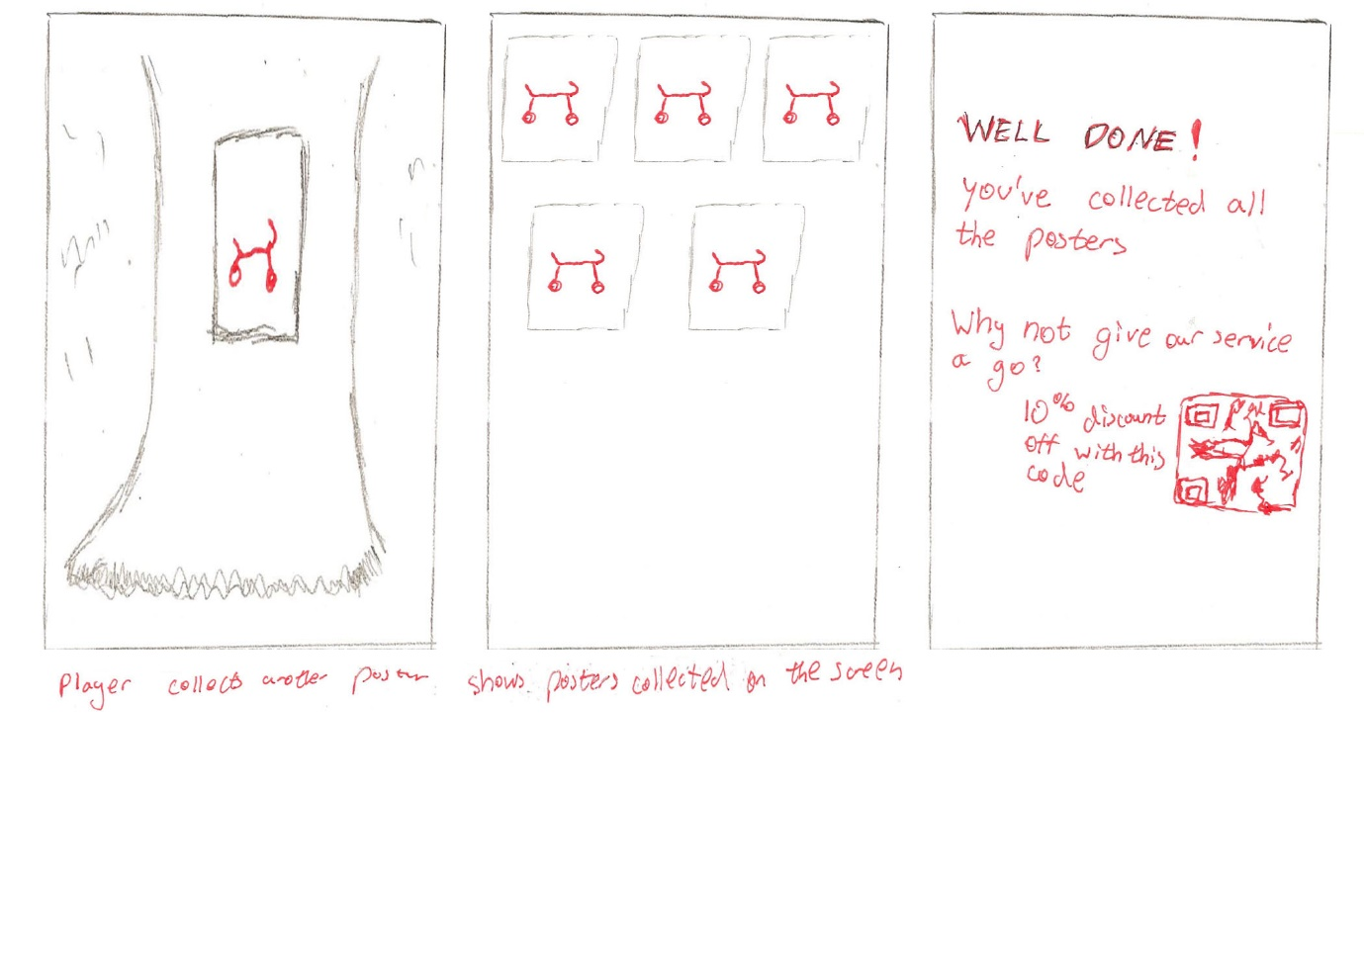

## Jacob’s Storyboard

## C:\Users\Dominiq\AppData\Local\Microsoft\Windows\INetCache\Content.Word\Jacob's_Storyboard.jpg

## Aaron’s Storyboard

## Dominic’s Storyboard (DONE)

## User Interface Sketches

# Project Plan

## Team Members

Dominic - Artist

Sharna - Designer

Jacob - Designer

Aaron – Programmer

WE NEED SOMETHING LIKE MICROSOFT PLANNER AND A GANTT CHART

NEED BREAKDOWNS/SUBSECTIONS I.E PROTOTYPES- LOW FIDELITY –SKETCHES/STORYBOARD-AARON/SHARNA

|  |  |  |  |  |  |
| --- | --- | --- | --- | --- | --- |
| ID | Task | Assigned to | Estimation | Priority | Progress |
| 1 | **Prototypes**  **(Sketches)** | **Dominic** | **2** | **6** | **80** |
| 2 | **Prototypes**  **(Sketches)** | **Aaron** | **4** | **6** | **70%** |
| 3 | **Prototypes**  **(Storyboard)** | **Sharna** | **5** | **6** | **99%** |
| 4 | **Prototypes**  **(Storyboard)** | **Jacob** | **7** | **6** | **100%** |
| 5 |  |  |  |  |  |